**Store Service, Product Service, Order Service**

**Store Service**: - For getting any Store by id

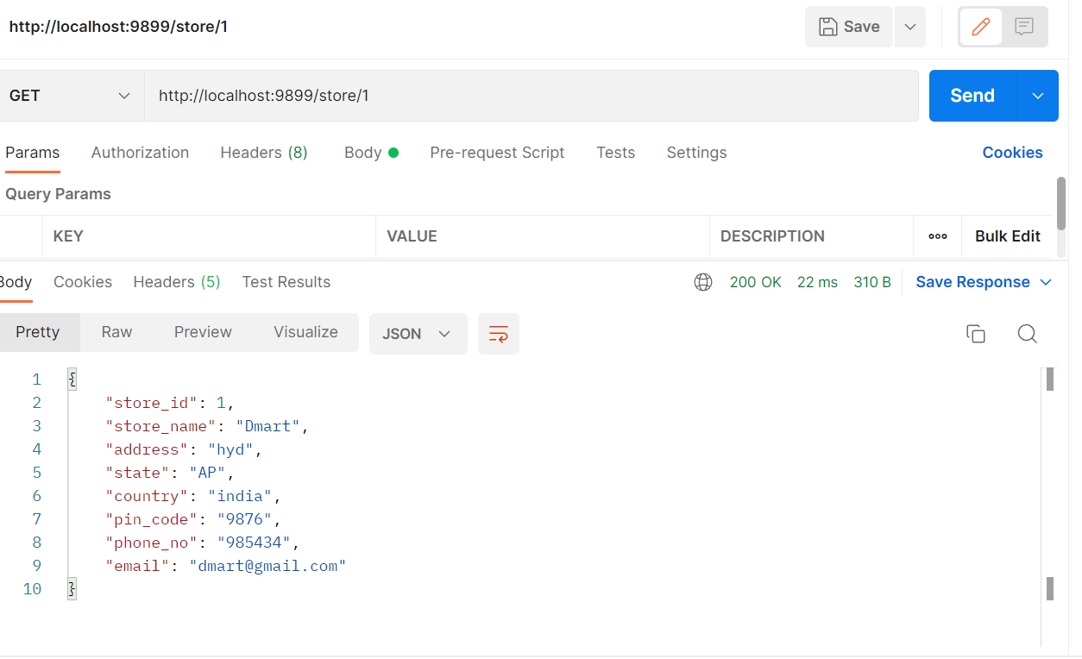

**Product Service**: - For getting any Product by id

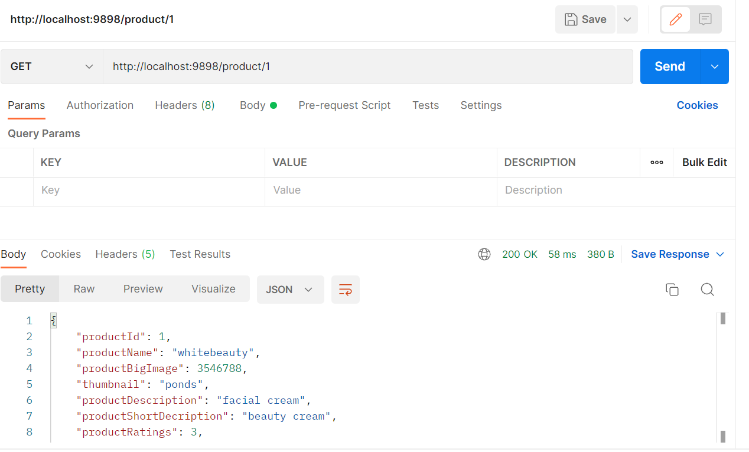

**Order Service**: - For getting any Order by id

**Order Service**: Get all the Orders

**Order Service**: Post Order

**Order Service**: Update Order by Id

**Order Service**: Delete the Orders by Id

**Order Service**: Delete the Orders by Id

